**Step 1: Create a Virtual Machine in Azure**

1. **Log in to the Azure Portal**:
   * Go to the [Azure Portal](https://portal.azure.com) and sign in with your account.
2. **Create a New Virtual Machine**:
   * In the Azure Portal, click on **"Create a resource"** from the left-hand menu.
3. **Configure the VM Basics**:
   * **Subscription**: Choose your subscription.
   * **Resource Group**: You can either create a new resource group or select an existing one.
   * **Virtual Machine Name**: Give your VM a name.
   * **Region**: Select **"West US"** from the dropdown menu.
   * **Availability Options**: Choose according to your needs (No infrastructure redundancy, Availability zone, etc.).
   * **Image**: Select **"Ubuntu"** from the list of available images (choose the specific version you need, e.g., Ubuntu 20.04 LTS).
   * **Size**: Choose the VM size based on your requirements.
4. **Configure Administrator Account**:
   * Choose the **Authentication type** (SSH public key or password). If using SSH, you'll need to generate an SSH key pair if you haven't already.
   * Enter the **Username** and **SSH public key** (if applicable).
5. **Configure Networking**:
   * Under the **Networking** tab, ensure a new virtual network and subnet are created or select an existing one.
   * Make sure to allow **Public IP** to connect to your VM.
6. **Open SSH Port**:
   * In the **Networking** section, add an inbound port rule to allow **SSH (port 22)**.
7. **Review + Create**:
   * Review your settings and click **"Create"** to provision the VM. This may take a few minutes.

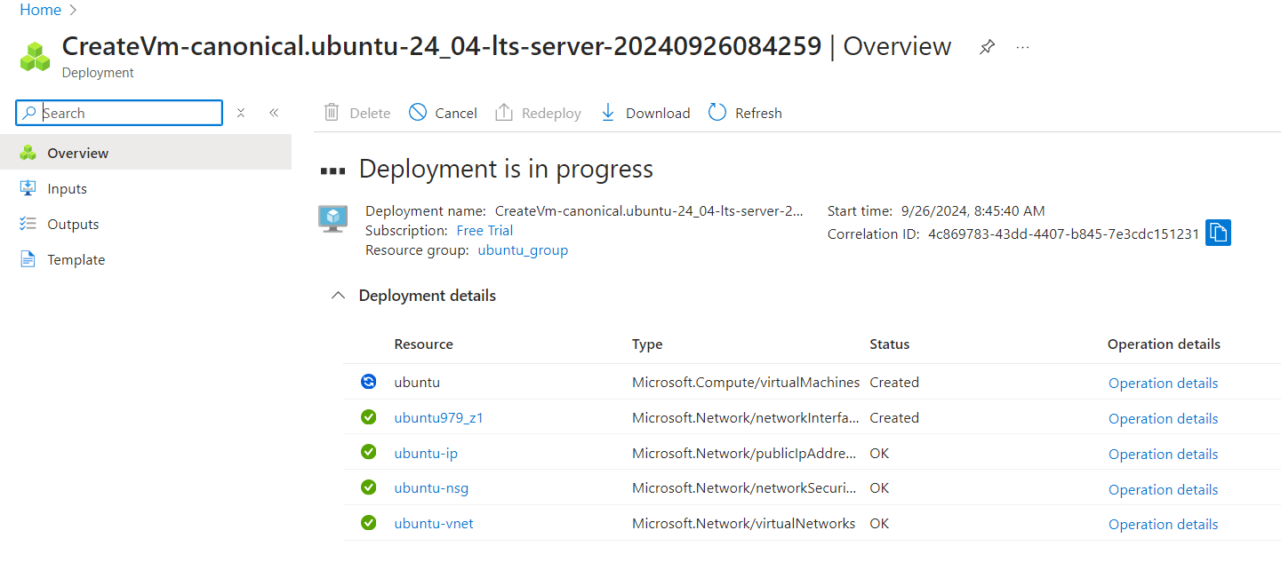

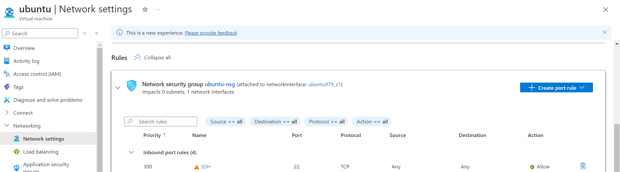

**Step 2: Connect to the Linux VM using Terminal**

1. **Get the Public IP Address**:
   * Once the VM is created, go to the **"Overview"** page of your VM in the Azure Portal.
   * Note the **Public IP address** of the VM.

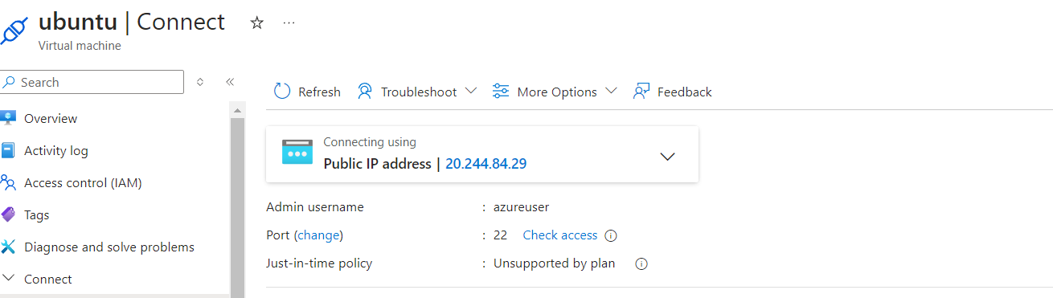

1. **Open Terminal**:
   * On your local machine, open a terminal (Linux, macOS, or Windows with WSL).
2. **Connect to the VM**:
   * Use the following command to connect via SSH:

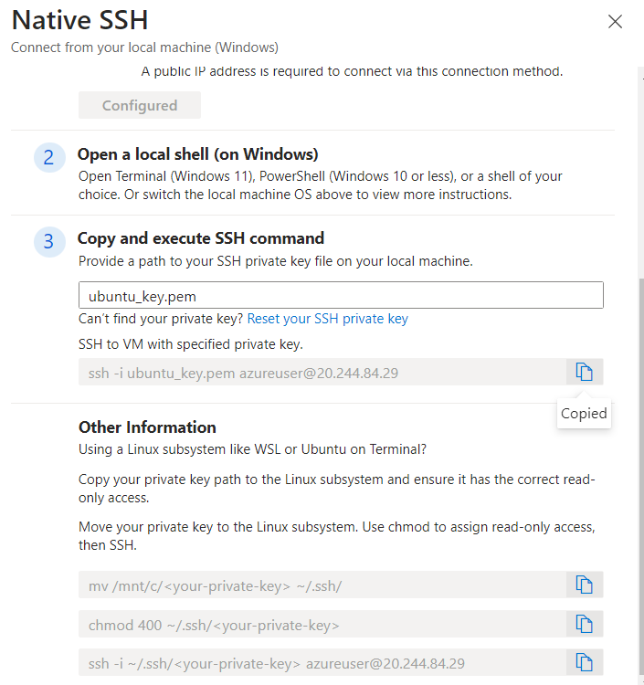

1. **Accept the SSH Key**:
   * The first time you connect, you'll be asked to confirm the authenticity of the host. Type **"yes"** and hit **Enter**.

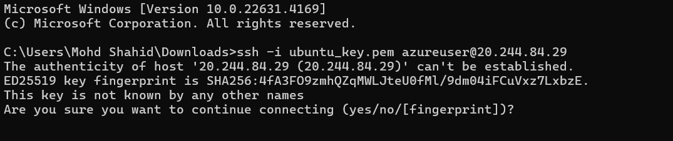

* + If you used a password for authentication, enter it when prompted.

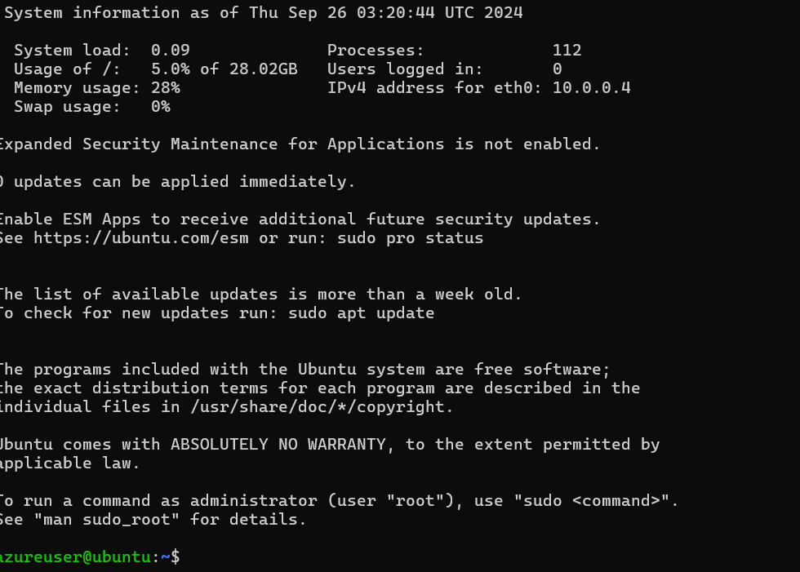

**Step 3: Install Docker**

Once connected to your VM, follow these steps to install Docker:

# Update the package index

**sudo apt update**

# Install Docker

**sudo apt install -y docker.io**

# Start Docker service

**sudo systemctl start docker**

# Enable Docker to start on boot

**sudo systemctl enable docker**

**Step 4: Pull the hshar/webapp Repository**

Now that Docker is installed, you can pull the hshar/webapp repository:

**docker pull hshar/webapp**

**Step 5: Create a New File in the Docker Image**

To create a new file in the hshar/webapp image, you’ll need to run a container from that image and then create the file within that container.

1. **Run a Container from the Image:**

**sudo docker run -it --name my_webapp_container hshar/webapp /bin/bash**

This command will start an interactive terminal session inside the container.

1. **Create a New File:** Inside the container, create a new file:

**touch new_file.txt**

**echo "This is a new file created in the hshar/webapp container." > new_file.txt**

1. **Exit the Container:** To exit the container while keeping it running:

**exit**

**Step 6: Create an Azure Container Registry and Connect It to Docker Running in VM**

1. **Create a New Container Registry:**
   * In the Azure Portal, click on "Create a resource."
   * Search for "Container Registry" and select it.
   * Click "Create."
2. **Configure the Container Registry:**
   * Fill out the necessary information (Subscription, Resource Group, Registry Name, Location, SKU).
   * Click "Review + Create" and then "Create."

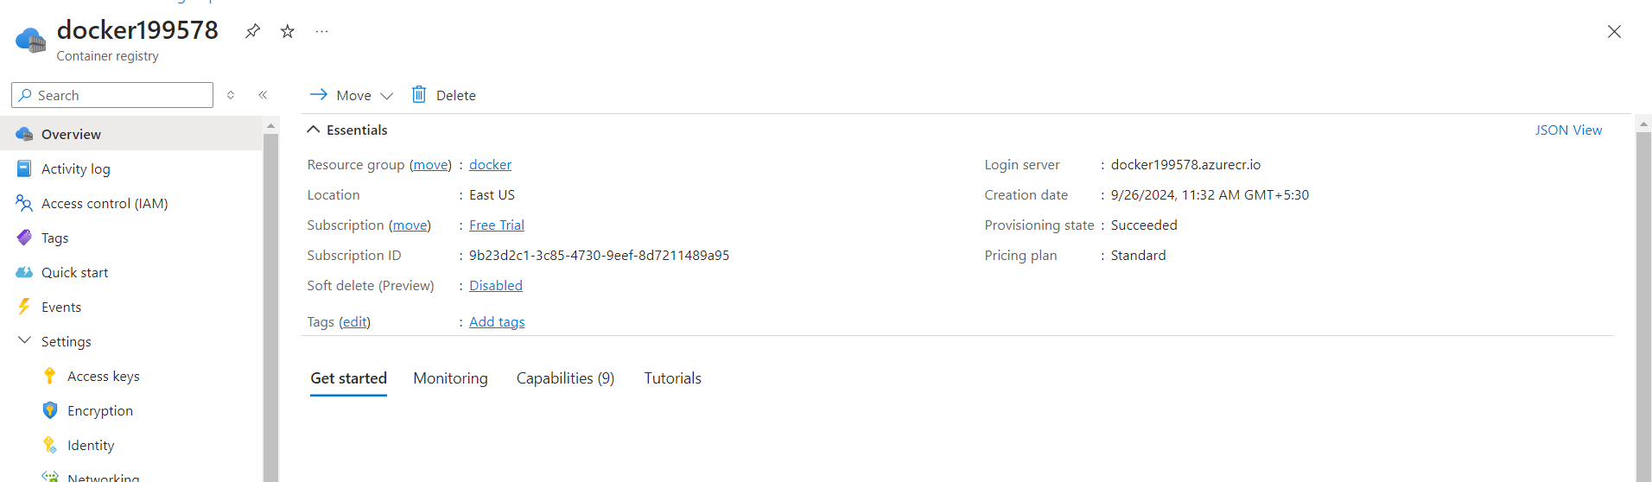

1. **Log in to the Azure Container Registry from the VM:**
   * Run the following command in your VM

**az acr login --name docker199578**

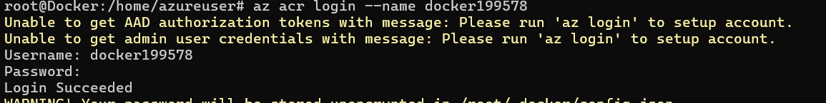

**Step 7: Upload the Image to Azure Container Registry**

1. **Tag the Docker Image:**

**sudo docker commit my_webapp_container docker199578.azurecr.io/my_webapp_image:latest**



1. **Push the Docker Image to the Registry:**

**sudo docker push docker199578.azurecr.io/my_webapp_image:latest**



**Step 8: Create an App Service to Deploy the Same Image**

1. **Create a New App Service:**
   * In the Azure Portal, click on "Create a resource."
   * Search for "Web App" and select it.
   * Click "Create."
2. **Configure the App Service:**
   * **Subscription:** Choose your subscription.
   * **Resource Group:** Use the same resource group as your Container Registry.
   * **Name:** dockerwebapp199578.
   * **Publish:** Choose "Docker Container."
   * **Operating System:** Select Linux.
   * **Region:** Choose the same region as your resources.
   * **App Service Plan:** Create a new plan or use an existing one.
3. **Configure Docker Settings:**
   * **Image Source:** Select "Azure Container Registry."
   * **Registry:** Choose your created container registry.
   * **Image:** Enter my_webapp_image.
   * **Tag:** Enter latest.

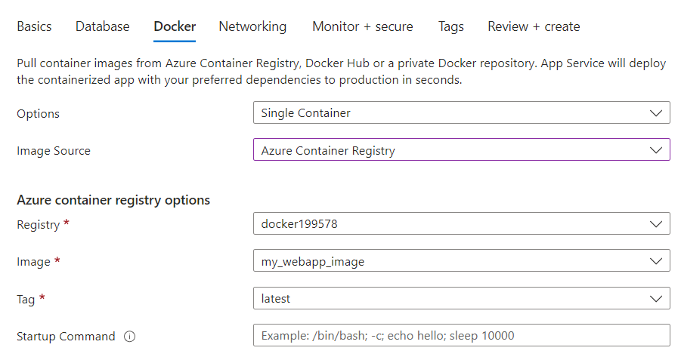

1. **Review + Create:**
   * Review your settings and click "Create."

